

Caution: Risk of Shock. Before Opening or Uninstalling the Computer System from Rack, ensure power has been removed from Power Supply(s) as applicable.

ESD Warning: Do not open the Computer System without proper ESD protective equipment and/or anti-static precautions in place.
Warning: As a result of this procedure, BIOS defaults will be loaded; any custom BIOS settings will need to be re-applied while returning the unit to service. Please note any custom settings before proceeding.
- Battery Replacement
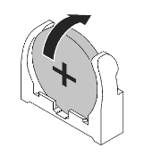
  - Battery location is dependent on your board model and form factor. The cell is located in either a vertical or horizontal retention assembly.
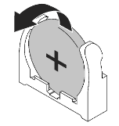
  - Vertical Cell Holder Procedure:
    - Note the orientation of the battery.
    - Grasp the battery between two fingers and gently pull upwards and away from the metallic negative contact.
Insertion
Operation
Removal Operation
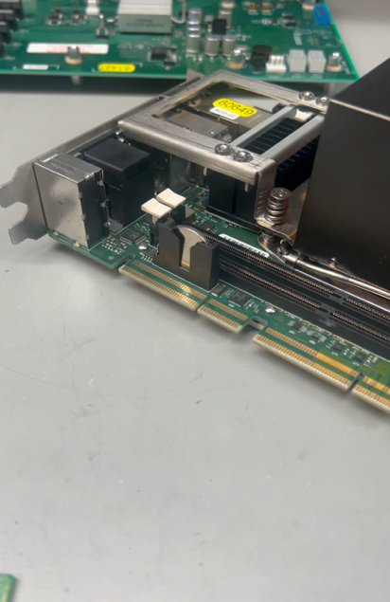
    - Note the manufacturer of the cell in your board and replace it with an equivalent.
      - Insert new battery, negative side toward the open (metallic negative contact), positive side pointed away into the bottom of the Vertical Cell Holder.
      - Gently apply force towards the metallic negative contact until it latches into position.
    - Return the unit to service.
Removal of Vertical Battery

- Horizontal Cell Holder Procedure:
    - Note the orientation of the battery.
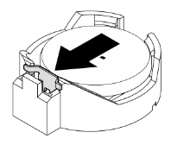
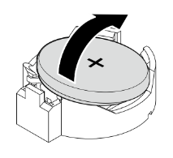
    - Depress the latching mechanism with a small implement and remove battery away from the latching mechanism.
    - Note the manufacturer of the cell in your board and replace it with an equivalent.
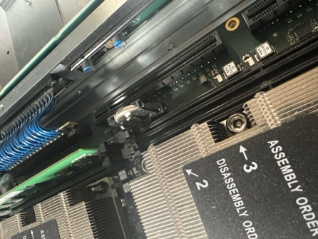
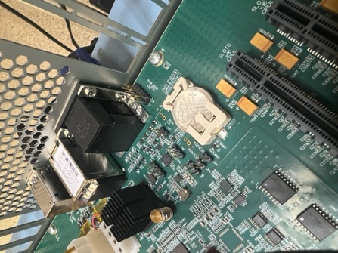
      - Insert new battery, positive side up, at a 45-degree angle on the side of the retention assembly opposite the Latching
Mechanism.
Remove from Horizontal Retention Assembly
Release Latching Mechanism
      - Gently press down on the Latching Mechanism side of the battery until it latches into position.
    - Return the Unit to Service.
- Trenton Systems Replacement CR2032 Battery PNs:
Example of Horizontal Battery – 2
Example of Vertical Battery – 1
    - Maxcell: 29-008017-000
    - Panasonic: 29-005774-000

