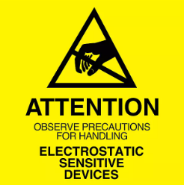
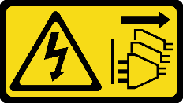
Caution: Risk of Shock. Before Opening or Uninstalling the Computer System from Rack, ensure power has been removed from Power Supply(s) as applicable.

ESD Warning: Do not open the Computer System without proper ESD protective equipment and/or anti-static precautions in place.
Warning: As a result of this procedure, BIOS defaults will be loaded; any custom BIOS settings will need to be re-applied while returning the unit to service. Please note any custom settings before proceeding.
- Chassis Cleaning
  - For Cleaning procedures, please refer to this Video:
Routine Maintenance for Trenton Systems Products - YouTube
  - General procedure:
    - Use canned compressed air to remove dust and debris from the front filter(s) [model dependent] accessible via the front face.
      - NOTE: Do not use air from an air compressor system that does not have static-arresting equipment.
    - Host Boards may be removed from backplanes for cleaning. Motherboard based systems should not be removed from the chassis and be cleaned via compressed air in-situ.
    - Check and Clean the Power Supply fan(s) if applicable.
    - Check and Clean the rear I/O area to ensure air egress.

