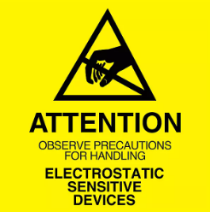
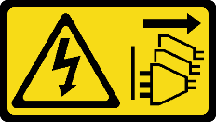
Caution: Risk of Shock. Before Opening or Uninstalling the Computer System from Rack, ensure power has been removed from Power Supply(s) as applicable.

ESD Warning: Do not open the Computer System without proper ESD protective equipment and/or anti-static precautions in place.
Warning: As a result of this procedure, BIOS defaults will be loaded; any custom BIOS settings will need to be re-applied while returning the unit to service. Please note any custom settings before proceeding.
- Removal of Boards / PCB Handling
  - Option cards (PCIe, OCP, etc.) and SHB(s) (HDEC and PICMG Host Boards) may be removed for service. In general, follow these precautions:
    - Always handle the board by the edges, away from any surface mount components.
    - Refer to section 2-B of this document for cleaning procedures for gold fingers.
  - Ensure any 6-32 Screws holding the SHB(s) or option cards to the chassis have been removed. There may be up to 3 of these (2 – rear, 1 – front) on HDEC [HEP8225, SEP8253].
  - Grasp the board by the edges front and rear away from any surface mount components and gently pry up. It may be necessary to alternate lifting one end of the board first then work the opposite end up to the same plane, “walking” the board out of the slot.
  - SHB gold finger contacts may be cleaned utilizing 90% Isopropyl Alcohol and a lint-free towel or cloth.
  - Return the unit to service by reinstalling the SHB(s).
    - Place the board directly over the slot and set into openings. Gently push the board into the slot alternating force from front to rear.
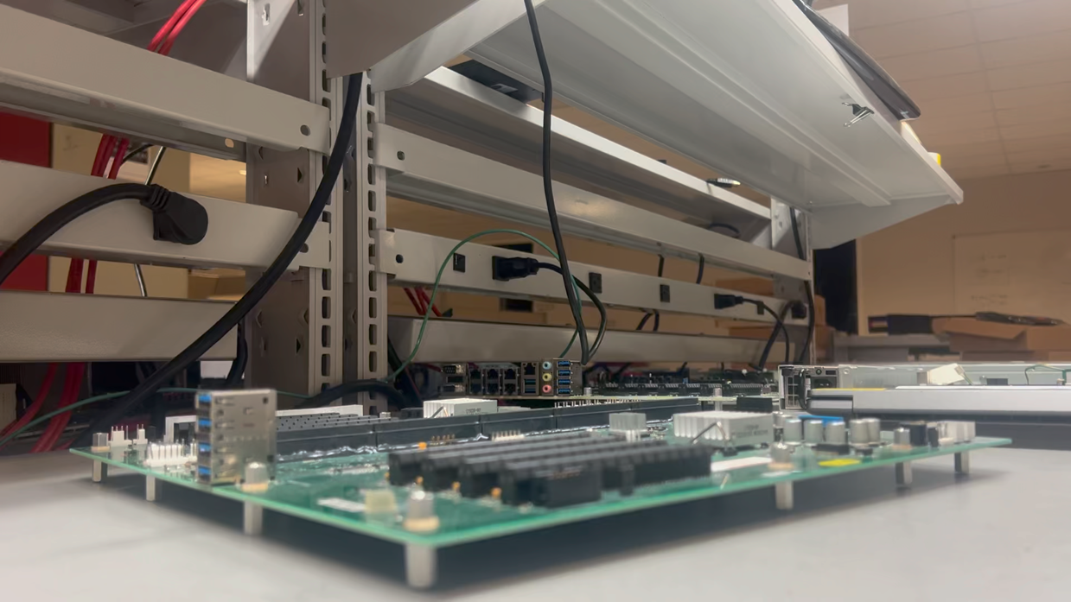
Reinstallation of SHB

